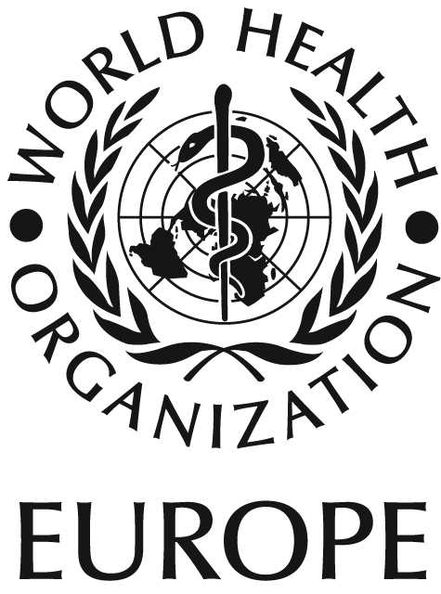

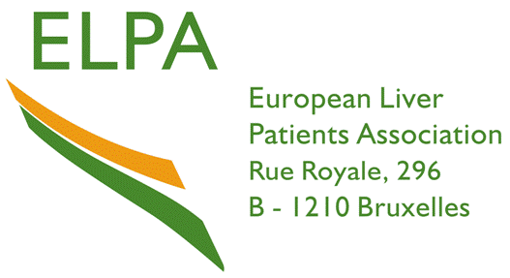

MEDIA RELEASE

International patient groups join Sir Bob Geldof and the World Health Organization Regional Office for Europe to urge people at risk from hepatitis to get tested

Sir Bob Geldof and World Health Organization (Europe) back call for immediate action on hepatitis
before it is too late

Copenhagen, Denmark 26 September 2006 (Embargo - 00.01 CET) Sir Bob Geldof today added his voice to that of hepatitis patient groups, the World Health Organization (WHO) Regional Office for Europe and the European Association for the Study of the Liver (EASL) by calling on governments around the world to prioritise hepatitis. Almost 600 million people worldwide are infected with either hepatitis B or C, both potentially life-threatening liver diseases. Of these, 350 million have hepatitis B despite WHO guidelines released in 1991¹recomending the addition of hepatitis B vaccination to all national immunization programmes.

New research from both WHO Europe and the European Liver Patient Association (ELPA) show inconsistencies in hepatitis testing, diagnosis and treatment across Europe and beyond. With increased movement across borders and the knowledge that a possible 86% of people with hepatitis C are unaware they have it (UK^{2,3}), these inconsistencies could have a lasting impact on the health of the global community. This has lead Sir Bob Geldof, WHO Europe and patient groups from around the globe to call on governments to take action now before there is an epidemic of liver disease.

Speaking in a pre-recorded message, Sir Bob Geldof highlighted the importance for those at risk, to get tested: “Stigma, shame and fear can suffocate awareness. These barriers prevent people from getting tested, receiving treatment and clearing themselves of this disease. The thing about the hepatitis C virus is that it does not cause any obvious symptoms. People can be infected with the virus for years and not know. This has led to people calling it a silent disease. The good news is that hepatitis C can actually be cured in many people. Seek advice from your doctor and ask about the risk factors for hepatitis C. The worst situation is to be diagnosed when the disease has progressed too far to be treated.”

Dr Marc Danzon, Director of WHO Europe recognises the importance of this global health threat. “Controlling hepatitis poses a significant challenge in the 21st century, and the number of people developing serious liver disease as a result of these viral infections continues to rise. WHO Europe, along with many other partners, is concerned about the high levels of infection, which in some areas of the world can be classified as highly endemic.”

Key findings of the ELPA survey conducted in 15 European countries include the following:

- Lack of national strategy: Only 4 of the 15 countries surveyed (France, Netherlands, Sweden, United Kingdom) have a national strategy for the prevention and treatment of hepatitis, and fewer than half reported that government funding was available to support patient associations in targeted initiatives.
- Stigma and discrimination: There are alarming levels of stigma and discrimination associated with viral hepatitis - 10 of the 15 countries reported that people with hepatitis are discriminated against politically, socially and economically.
- Screening and diagnosis: While screening is free in 9 of the 15 countries surveyed, government-organized programmes to promote screening exist only in two countries (France and the Netherlands.) In addition, 14 of the 15 countries do not run annual screening programmes. Many countries (e.g. Austria, Bosnia and Herzegovina, Romania and Switzerland) consider screening difficult to access, and in 5/15 countries patients have to pay for the test.
- Reimbursement and access to treatment needed: There are large variations in reimbursement and access to treatment. While many countries in the ELPA survey reported 100% coverage of hepatitis C treatment costs, Bosnia and Egypt offered no reimbursement, Belgium only 85% and Switzerland 90% of costs. According to a recent WHO Europe survey, Latvia reimburses 75% of hepatitis C treatment costs, while people with hepatitis in the other former Soviet Union countries must cover the cost of medication themselves.

Muriel Colinet, President of ELPA explained that “the research presented today clearly demonstrates the need for a unified European approach; including free screening across Europe. It is crucial that anyone who feels that they may be at risk from this virus are tested as soon as possible.”

Many pivotal organizations, including WHO Europe, the European Commission, ELPA and EASL, convened in advance of World Hepatitis Awareness Day (held annually on Sunday October 1) at the WHO Europe in Denmark to hear about this new data. Delegates heard of the urgent need for improved rates of testing and diagnosis as well as access to treatment in all countries to ensure that hepatitis does not become the next global epidemic.

Delegates heard from Dr Jean-Michel Pawlotsky, Scientific Secretary of EASL, who explained that with early diagnosis and treatment, the majority of hepatitis B and C patients can be treated effectively. “People with hepatitis C can achieve a sustained viral response, the clinical equivalent of a cure. Treatment options over the last decade have improved significantly and it is fundamental that patients are tested and diagnosed as early as possible if they are to stand the best chance of clearing the virus. Issues and unresolved questions remain however, and it is mandatory that basic and clinical research on viral hepatitis be put very high on the agenda of worldwide stakeholders including political and funding bodies.”

In a call to action, Dr Marc Danzon, Director, WHO Europe added “As a disease that affects over half a billion people worldwide, WHO Europe believes it is an urgent priority for all stakeholders including doctors, governments and non-governmental organizations around the world do more to raise awareness of hepatitis B and C and to stop the spread of one of the greatest threats to the health of mankind today.”

About World Hepatitis Awareness Day
Now in its third year, World Hepatitis Awareness Disease, which takes place on October 1, 2006, aims to increase awareness about hepatitis B and C. This year, Sir Bob Geldof, WHO Europe, the EASL, ELPA and approximately 20 international patient organizations are working together to promote this important educational initiative. The theme for this year is Get Tested. Both forms of viral hepatitis can lead to cirrhosis, liver cancer and liver transplantation and yet hepatitis B can be prevented through immunisation and in many cases, hepatitis C can be cured. Hence WHO Europe has today released three hepatitis prevention, treatment and care protocols for the European Region (available at www.euro.who.int/aids).

Further information about hepatitis can be found on

www.elpa-info.org www.worldhepatitisawarenessday.com www.hep-links.com

Information for Broadcast Journalists

B-Roll footage of Sir Bob Geldof, Charles Gore from the Hepatitis C Trust as well as two case studies will be available on APTN transmission at 14.15 – 14.30 GMT on Monday 25th September. The transmission will be repeated at 09.15 – 09.30 GMT on Tuesday 26th September. For APTN transmission queries or further details, contact Medialink on +44 207 554 2703 / 2704.

For more information, please contact:
Muriel Colinet,
President, ELPA (Europe) and Carrefour Hépatites – Aide et Contact asbl (Belgium)
Phone: 32 (0) 61 26 68 90
chacasbl@skynet.be

Dr Srdan Matic
Regional Adviser, HIV/AIDS and Sexually Transmitted Infections
WHO Regional Office for Europe
Scherfigsvej 8, DK-2100 Copenhagen Ø, Denmark
Tel.: +45 39 17 16 06
Fax: +45 39 17 18 75
E-mail: sma@euro.who.int

References:

1 World Health Organization. Fact Sheet No. 204: Hepatitis B. 2000. www.who.int/mediacentre/factsheets/fs204/en/.

2 Health Protection Agency. Hepatitis C laboratory reports: England and Wales, 1992-2004. http://www.hpa.org.uk/infections/topics_az/hepatitis_c/data_lab_sex.htm.

3 Scottish Executive. Hepatitis C: essential information for professionals. http://www.scotland.gov.uk/Publications/2002/07/15074/8613.

